LuckyHomes Pvt Ltd

Software Requirements Specification

Version 1.0

13-June-2016

ModularFour Solution Pvt Ltd.

Revision History

Date | Description | Author | Comments

Document Approval

The following Software Requirements Specification has been accepted and approved by the following:
Signature | Printed Name | Title | Date

Table of Contents

Revision History ii
Document Approval ii
1. Introduction 1
1.1 Purpose 1
1.2 Scope 1
1.3 Definitions, Acronyms, and Abbreviations 1
1.4 References 1
1.5 Overview 1
2. General Description 2
2.1 Product Perspective 2
2.2 Product Functions 2
2.3 User Characteristics 2
2.4 General Constraints 2
2.5 Assumptions and Dependencies 2
3. Specific Requirements 2
3.1 External Interface Requirements 3
3.1.1 User Interfaces 3
3.1.2 Hardware Interfaces 3
3.1.3 Software Interfaces 3
3.1.4 Communications Interfaces 3
3.2 Functional Requirements 3
3.2.1 <Functional Requirement or Feature #1> 3
3.2.2 <Functional Requirement or Feature #2> 3
3.3 Use Cases 3
3.3.1 Use Case #1 3
3.3.2 Use Case #2 3
3.4 Classes / Objects 3
3.4.1 <Class / Object #1> 3
3.4.2 <Class / Object #2> 3
3.5 Non-Functional Requirements 4
3.5.1 Performance 4
3.5.2 Reliability 4
3.5.3 Availability 4
3.5.4 Security 4
3.5.5 Maintainability 4
3.5.6 Portability 4
3.6 Inverse Requirements 4
3.7 Design Constraints 4
3.8 Logical Database Requirements 4
3.9 Other Requirements 4
4. Analysis Models 4
4.1 Sequence Diagrams 5
4.3 Data Flow Diagrams (DFD) 5
4.2 State-Transition Diagrams (STD) 5
5. Change Management Process 5
A. Appendices 5
A.1 Appendix 1 5
A.2 Appendix 2 5

1. Introduction
Currently the Finsoft System Does not Print the Particulars of the Settlement of the Customer. Therefore Lucky Home Needs to Print the Particulars of the customer at the point of Receipting.

1.1 Purpose
This is to elaborate on the Requirement that Lucky Home Need to Change the Receipt Printing.

1.2 Scope
This subsection should:
(1) Receipt Printing

1.3 Definitions, Acronyms, and Abbreviations
N/A

1.4 References
Refer the Attached Report Format

1.5 Overview

2. General Description
Receipt Printing

2.1 Product Perspective
Receipting

2.2 Product Functions
Receipt

2.3 User Characteristics

2.4 General Constraints
1. Default charges - this should be separately mentioned in the receipt.
2. Final Payment - if customer pay the final payment.
3. EP Rental - Easy Payment Rental
4. Non Refundable Advance
5. Further Advance

2.5 Assumptions and Dependencies
N/A

3. Specific Requirements
1. Default charges - this should be separately mentioned in the receipt.
2. Final Payment - if customer pay the final payment.
3. EP Rental - Easy Payment Rental
4. Non Refundable Advance
5. Further Advance

3.1 External Interface Requirements

3.1.1 User Interfaces

3.1.2 Hardware Interfaces

3.1.3 Software Interfaces

3.1.4 Communications Interfaces

3.2 Functional Requirements
Once Customer Settle the Outstanding with Receipt, System Needs to print the Receipt According to the Particulars and the relevant amount in the receipt as below mention

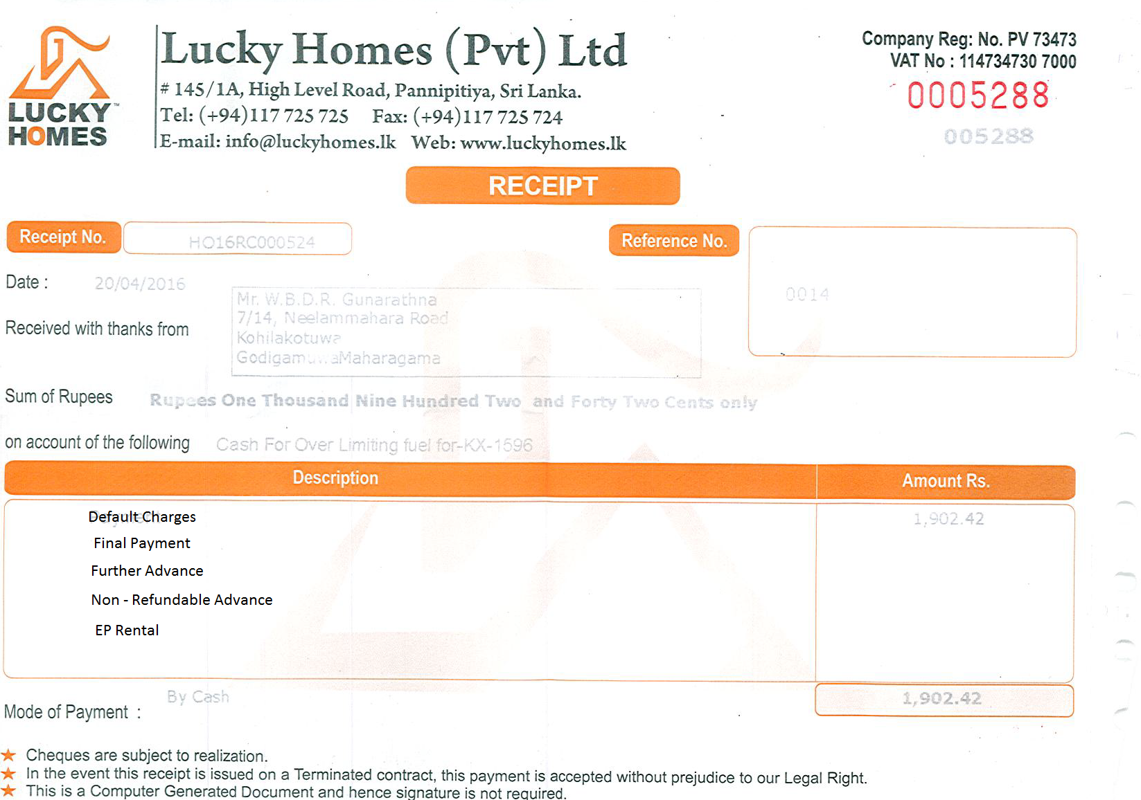

3.2.1 <Functional Requirement or Feature #1>
3.2.1.1 Introduction
3.2.1.2 Inputs
3.2.1.3 Processing
3.2.1.4 Outputs
3.2.1.5 Error Handling

3.2.2 <Functional Requirement or Feature #2>
…

3.3 Use Cases

3.3.1 Use Case #1

3.3.2 Use Case #2
…

3.4 Classes / Objects

3.4.1 <Class / Object #1>

3.4.1.1 Attributes
3.4.1.2 Functions

3.4.2 <Class / Object #2>
…

3.5 Non-Functional Requirements

3.5.1 Performance

3.5.2 Reliability

3.5.3 Availability

3.5.4 Security

3.5.5 Maintainability

3.5.6 Portability

3.6 Inverse Requirements

3.7 Design Constraints

3.8 Logical Database Requirements

3.9 Other Requirements

4. Analysis Models

4.1 Sequence Diagrams

4.3 Data Flow Diagrams (DFD)

4.2 State-Transition Diagrams (STD)

5. Change Management Process

A. Appendices

A.1 Appendix 1

A.2 Appendix 2

